Verkefni 1 – VÉL608G
Íslenska

Verkefnislýsing
Fyrsta verkefnið felst í að búa til vefsíðu sem hýsir vinnuframlag mitt (portfolio) í áfanganum Tölvustudd framleiðsla. Hér að neðan lýsi ég ferlinu við gerð vefsíðunnar með texta og myndum, þar sem ég fer yfir val á sniðmáti og helstu hönnunarákvarðanir. Ég segi einnig frá því hvað ég vil fá út úr áfanganum og hugmyndum mínum að lokaverkefni. Að lokum útskýri ég hvernig ég hlóð síðunni upp á GitHub, hvaða áskoranir komu upp og hvernig ég leysti þær.
Undirbúningur og upplýsingaöflun
Til undirbúnings við vefsíðugerðina, byrjaði ég lesa verkefnislýsinguna vandlega og horfði á kennslumyndböndin á Youtube sem innihalda leiðbeiningar verkefnisins. Eftir að hafa aflað nokkrum upplýsingum og fengið grófa hugmynd um hvernig ég vildi að vefsíðan mín liti út, hlóð ég niður ráðlögðum hugbúnaðum fyrir verkefnið. Ég hlóð niður hugbúnaðinum Brackets frá http://brackets.io/, sem er handhægur ritill fyrir kóðamál eins og HTML, CSS o.fl., hann gerir manni kleift að sjá forskoðun á vefsíðunni í beinni eftir að breytingar hafa verið gerðar.

Enska
Introduction
The first assignment involves creating a website that hosts my work (portfolio) for the course VÉL608G Modern manufacturing processes. Below, I describe the process of building the website using text and images, including how I chose a template and the key design decisions I made. I also explain what I hope to gain from the course and share my ideas for a possible final project. Finally, I describe how I uploaded the site to GitHub, what challenges came up, and how I solved them.

Preparation and Research
To prepare for building the website, I first read the assignment description carefully and watched the YouTube tutorial videos provided for the project. I also reviewed the websites created by Sæmundur Guðmundsson (2022), Aron Dagur Beck (2023), and Aðalsteinn Ari Gunarsson (2024). Their work gave me a clear overview of how to approach the assignment and helped me form a rough idea of the layout and overall style I wanted for my own site. After that, I downloaded the recommended software and installed Brackets (http://brackets.io/), a convenient code editor for languages such as HTML and CSS. Brackets also support live preview, which made it easier to test and refine changes as I worked. I then created a GitHub account https://github.com/martthanawin30 to be able to launch the website, and downloaded git Bash from Git: https://git-scm.com/ to save the project to my repository.
Since I have little to no experience with HTML and CSS, I read the beginner guides on W3Schools and also got help from ChatGPT. After that, I watched introductory videos on using Brackets and editing HTML websites:
- https://www.youtube.com/watch?v=FuXzV8o7Y9c
- https://www.youtube.com/watch?v=pC0oi-4dAZI

Building the website
My design goals for a personal website were to create a clean, modern layout that keeps the focus on my projects, making it well suited for a portfolio. I also wanted the site to have smooth, easy scrolling between sections, a drop-down menu, and clear navigation, so it would be easy to organize content into sections and subpages such as Projects, a CV, and an introduction about myself. After gathering the necessary information and tools for the project, I explored different templates on https://html5up.net/. Ultimately, I chose the Landed template because it fits my portfolio needs well and matches my design goals. Then I downloaded the template and opened index.html file in Brackets, where I began customizing and refining the website to match my requirements.

Customizing the website to my requirements
First, after opening the index.html file in Brackets, I changed the main display of home page, changing the title to my name, the main banner, and other texts.
Creating and deleting unwanted sections and pages
To create subpages for each assignment under the main page (VÉL608G Assignments), I used the template’s generic.html file as a starting point. I copied it into my project folder (website_portfolio) and renamed each copy to Project1.html, Project2.html, and so on. I then linked these pages from index.html by updating the drop-down menu and the “Learn More” buttons, so the pages can be accessed through the top-right navigation as well. Below, is how the code for the top-right navigation bar looked like:
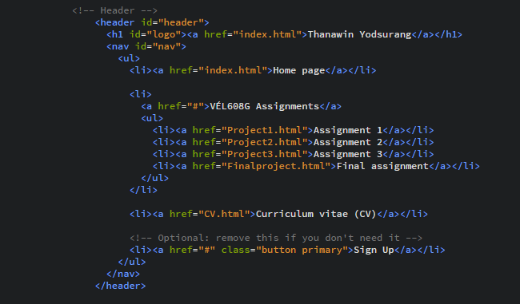
Here is the new look of the top-right navigation bar:
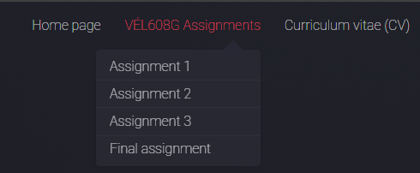
Appearance of the top-right navigation bar including a drop-down menu
I enabled the “Next” arrows on the home page by giving each <section> a unique id (e.g., A1, A2) and linking each arrow to the next section using href="#A2" and the goto-next scrolly classes. This makes the page scroll smoothly to the section below. The image shows how three sections are linked.
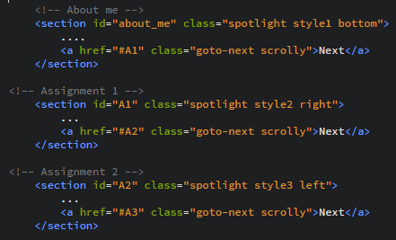
Code showing how unique section IDs are linked with “Next” anchor references to enable smooth scrolling between sections.
I removed sections and elements that I felt were unnecessary, such as the Sign-Up button in the top-right corner and the “Get Started” email sign-up banner at the bottom of the home page.

The footer
I kept the main social/contact icons in the footer—Facebook, LinkedIn, GitHub, and email—and linked each icon to the correct destination on every page. In addition, I added a “Get in contact” heading above the icons along with my phone number and email address. I used the same icon syntax that the Landed template already includes, and I also used W3Schools and ChatGPT for guidance on linking and styling the social media buttons. The following images show part of the footer code and how the footer appears on the website.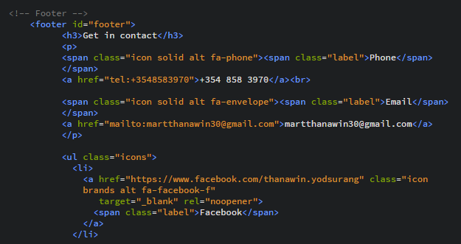
Part of the footer code
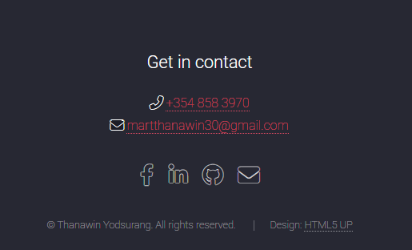
Appearance of the footer on the website

CV:
To add my CV, I first renamed the elements.html file to CV.html and removed the original placeholder content. My goal was to display the CV as a PDF directly on the page, so I used ChatGPT for guidance on embedding a PDF in HTML. The final CV page includes an embedded PDF viewer and a link that opens the document in a new browser tab. The main embed code looks like this:
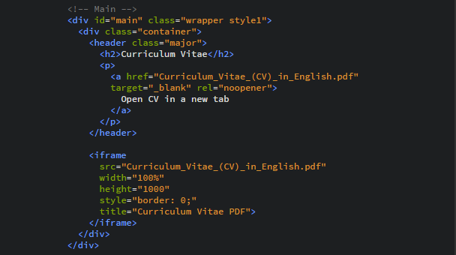
The following HTML code shows the core syntax used to display a PDF file within an embedded page frame using an <iframe> tag:
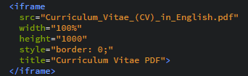
Displaying a pdf file using <iframe>

The CV page currently has this look:
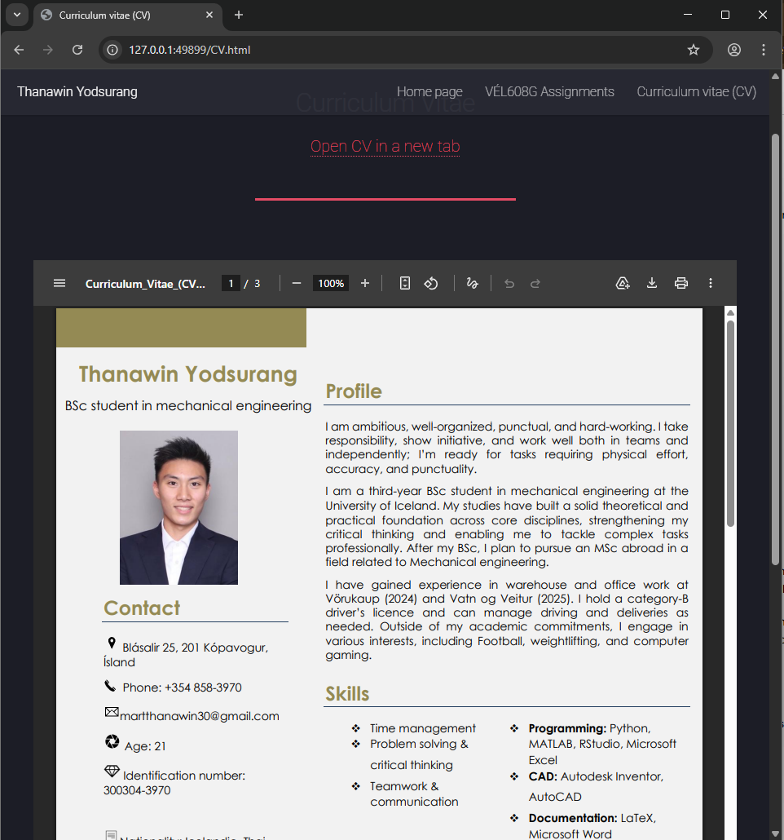
Image of the CV uploaded as a pdf document on the CV page
Editing texts
To learn how to edit the text, I located the relevant content sections in the HTML files and compared them with how they appeared on the website. I found that paragraphs are written using the <p> text</p> tag, and headings are written using <h1> header </h1>, <h2> header </h2>, and so on. The number in the heading tag indicates the heading level, ranging from 1 (largest) to 6 (smallest).
In addition, I learned that the visible content of a webpage is placed inside the <body> ... </body> tag. Within the body, the template organizes content into blocks using <section> and <div> elements. A <section> typically represents a meaningful part of the page (for instance, an “Introduction” or “building the website” section), while a <div> is a more general-purpose container used to group elements together for layout and styling with CSS. I used the <code> element to highlight HTML tags and other key terms that I wanted to emphasize in the text. To create lists in HTML, it is possible use either an unordered list (<ul>) for bullet points or an ordered list (<ol>) for numbered items. In both cases, each list entry is written using a list item tag (<li>).
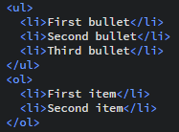
Bullet points listed with <ul> and numbered items listed with <ol>
Other useful HTML text-formatting elements can be found on the W3Schools page on HTML formatting (https://www.w3schools.com/html/html_formatting.asp). Below is a list of a few examples:
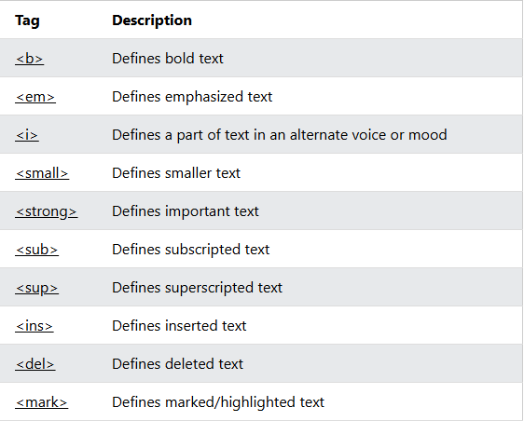
list of a few examples HTML text-formatting elements
Adding links:
To add links within a text, I learned (with help from ChatGPT) that a simple and convenient way to include and display a hyperlink to another website is to use (<a>), an anchor tag, and (href:), hypertext reference attribute, which specifies the destination URL or location. The code is the following:
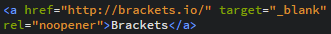
A code to display a link within a text.

Displaying images and videos
To display JPG images with captions, I asked ChatGPT for a convenient approach and used the following HTML syntax together with template classes to control alignment and ensure the images scale correctly on the page.
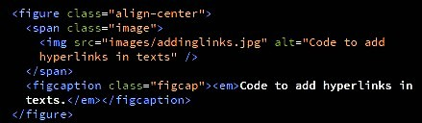
For screenshots, I used the built-in editor on my computer to improve readability and visibility.

Styling with CSS
mark {
background-color: yellow;
color: black;
}

